Balance Transfer Unit
Project Title: Balance Transfer Unit – Design & Development
Objective:
Designed and developed a rotary adjustment mechanism for a precision fertilizer spreader, enabling accurate and repeatable positioning of the operating setting through controlled rotary motion.
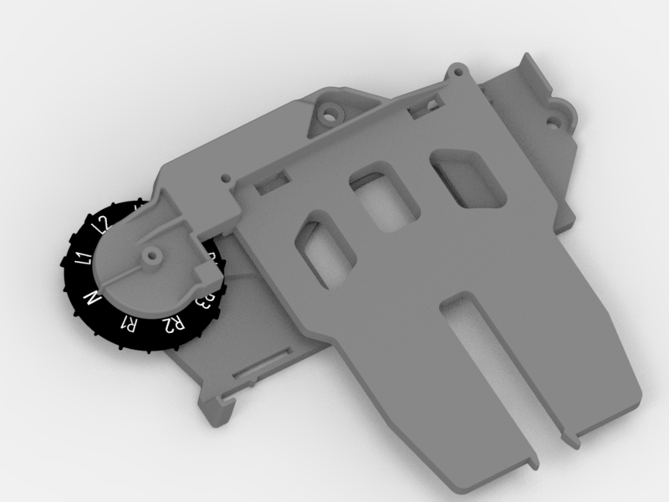

Key Design & Development Activities
- Developed the 3D CAD model of the balance transfer unit and supporting components.
- Designed a rotary adjustment mechanism to achieve multiple predefined operating positions.
- Integrated a graduated rotary scale for easy and precise setting selection.
- Converted rotary knob movement into controlled positional adjustment of the spreader mechanism.
- Developed the housing, mounting features, locating points, and locking arrangement.
- Optimized the mechanism for repeatability, smooth operation, and positional accuracy.
- Checked clearances, interference, and fitment of the rotating and stationary components.
- Considered injection-moulding DFM, assembly, and manufacturability during design.
- Validated the mechanism through prototype/trial testing and incorporated improvements based on observations.
Key Benefits
- Precise and repeatable adjustment
- Easy operator control
- Multiple predefined settings
- Compact and robust mechanism
- Improved spreading-setting accuracy
- Reduced chances of incorrect adjustment

Outcome
Designed and developed a rotary-motion-based adjustable positioning mechanism for a precision fertilizer spreader, providing accurate, repeatable, and user-friendly control of spreading settings through a graduated rotary adjustment system.

